Exercise 2: Configuring IP Extended Access Lists

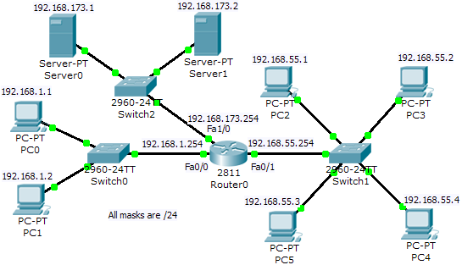

- Now, design your own ACL based on the following security policy: (Assume that Server0 and Server1 only offers FTP, and Web services)
- PC4 can only ping PC0, but not Server0, Server1 and PC1 (of other subnets).
- PC4 can only access the FTP services of Server1.
- 192.168.1.0/24 can’t access web service of Server1 but web service of Server0.
- 192.168.55.1 and 192.168.55.3 can only access the FTP service of Server0.

Answer:

To fulfill rule (a) and (b):
#access-list 102 permit icmp host 192.168.55.4 host 192.168.1.1
#access-list 102 permit tcp host 192.168.55.4 host 192.168.173.2 eq ftp
#access-list 102 deny ip host 192.168.55.4 any
#access-list 102 permit ip any any
#int fa0/1
#ip access-group 102 in

To fulfill rule (c) and (d):
#access-list 103 deny tcp 192.168.1.0 0.0.0.255 host 192.168.173.2 eq www
#access-list 103 permit tcp 192.168.1.0 0.0.0.255 host 192.168.173.1 eq www
#access-list 103 permit tcp host 192.168.55.1 0.0.0.2 host 192.168.173.1 eq ftp
#access-list 103 deny ip host 192.168.55.1 0.0.0.2 any
#access-list 103 permit ip any any
#int fa1/0
#ip access-group 103 out

